**American Samoa Boat-based creel survey data to Year 2021**

Penglong Tao[1]

Requestor/Agency: Erin Bohaboy, FRMD

**Purpose:** Erin requests American Samoa Boat-based creel survey dataset with similar output format to PICDR-113127  
and Code files for Species and Method

**Reference**: PICDR-113156

**Data Sources** (from MySQL server finfish):

* amsam_dmwr.a_bbs_interview_flat_view
* amsam_dmwr.a_species
* amsam_dmwr.a_method

**Data Deliver Methods**:

* Approval is granted by Keith and Brent.
* Saved flat_view data from MySQL server to csv files in local W drive:  
  The file is too huge to save, so I saved four split pieces:  
  a_bbs_int_flat1: 1985 – 1997;  
  a_bbs_int_flat2: 1998 – 2005;  
  a_bbs_int_flat3: 2006 – 2012;  
  a_bbs_int_flat4: 2013 – 2021.
* Use Kiteworks to transfer four Flat files to Erin securely:  
  It’s website: <https://sfc.doc.gov/>  
  Compose an email

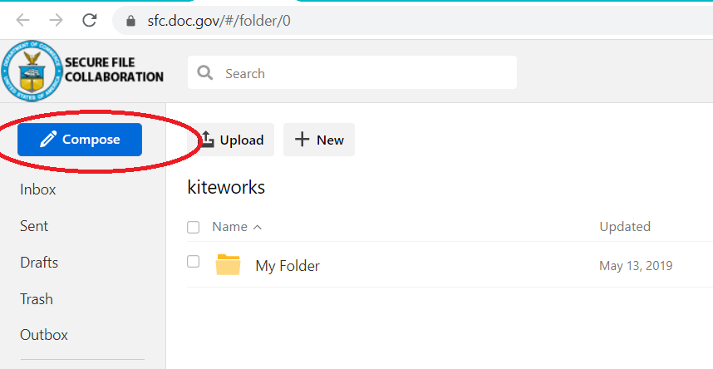

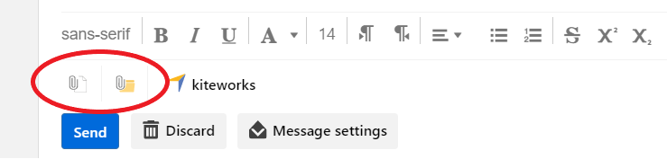Attach files and send

* Attached code files (Species, Method) to JIRA site directly.

1. Fisheries Research and Monitoring Division, WPacFIN Program, Pacific Islands Fisheries Science Center (PIFSC), NOAA Inouye Regional Center, 1845 Wasp Boulevard, Building 176, Honolulu, HI 96818